**BJS11159**

**Meta-analysis of the outcomes of treatment of internal carotid artery near occlusion**

A. J. A. Meershoek, E. E. de Vries, D. Veen, H. M. den Ruijter and G. J. de Borst, on behalf of the NEON study group

# Appendix S1 NEON study group

A. Garcia-Pastor, Hospital General Universitario Gregorio Maranon, Madrid, Spain

A. Gonzalez, Virgen del Rocio University Hospital, Seville, Spain

E. Johansson, Umea University, Umea, Sweden

Y. Matsuda, Wakayama Medical University, Wakayama, Japan

T. Ogata, Fukuoka University, Fukuoka, Japan

F. Oka, Yamaguchi University School of Medicine, Yamaguchi, Japan

R. Pulli, University of Bari, Bari, Italy

S. Sakamoto, Hiroshima University Graduate School of Biomedical and Health Sciences, Hiroshima, Japan

S. Tanaskovic and D. Radak, Dedinje Cardiovascular Institute, Belgrade, Serbia

S. Son, Gyeongsang National University School of Medicine, Jinju, South Korea

# Table S1 Search strategy

|  |  |
| --- | --- |
| **carotid artery** | **Near occlusion** |
| carotid stenosis[MeSH] | near occlusion; near-occlusion; critical stenosis; string sign; string signs; slim sign; slim signs; pseudo-occlusion; pseudoocclusion; incomplete occlusion; subtotal stenosis; sub total stenosis; subocclusion; hairline residual lumen; near total internal occlusion; sub-occlusion; carotid hypoplasia; subtotal occlusion; hairline lumen; near total occlusion; internal occlusion; near total internal occlusion; near occlusion stenosis; pre-occlusive stenosis; pre occlusive stenosis; preocclusive stenosis; pre-occlusion; pre occlusion; preocclusion; functional occlusion; incomplete occlusion; poststenotic narrowing; small distal internal carotid artery; small distal carotid artery; narrow distal carotid artery; narrow distal internal carotid artery; functional occlusion; 99% stenosis; 99 percent stenosis |
| carotid |  |
| carotis |  |
| Both columns were linked with “AND”, while subsequent rows were linked with “OR”. | |

# Table S2 Quality assessment

|  |  |  |  |  |  |  |  |  |  |  |  |  |
| --- | --- | --- | --- | --- | --- | --- | --- | --- | --- | --- | --- | --- |
|  |  | | **Newcastle–Ottawa Scale for cohort studies** | | | | | | | |  | |
| **Reference** |  | Representative cases | | Selection of controls | Ascertainment of exposure | Outcome not present at start | Comparability of groups | Outcome assessment | Follow-up duration | Follow-up completeness | | Total points | |
| Regina 19978 |  | ● | | - | ● | o | - | ● | ● | ● | | 5 | |
| Radak 20109 |  | ● | | ● | ● | o | ●● | ● | ● | ● | | 8 | |
| Gonzalez 201110 |  | ● | | - | ● | ● | - | ● | ● | ● | | 6 | |
| Ogata 201111 |  | ● | | ● | ● | o | o * | ● | ● | ● | | 6 | |
| Oka 201312 |  | ● | | - | ● | o | - | ● | ● | ● | | 5 | |
| Son 201313 |  | ● | | - | ● | o | - | ● | ● | ● | | 5 | |
| Sakamoto 201314 |  | ● | | - | ● | o | - | ● | ● | ● | | 5 | |
| Johansson 201515 |  | ● | | ● | ● | ● | o * | ● | ● | ● | | 7 | |
| Matsuda 201616 |  | ● | | - | ● | o | - | ● | ● | ● | | 5 | |
| Garcia Pastor 201717 |  | ● | | - | ● | o | - | ● | ● | ● | | 5 | |
| Meershoek 201818 |  | ● | | - | ● | o | - | ● | ● | ● | | 5 | |

Symbols: ● consistent with criteria; o not consistent with criteria; - not applicable;

* comparability could not be determined due to the small group sizes

Footnotes: The maximum awarded amount of points for each item is one, except for the item comparability where the maximum awarded amount of points is two. The total amount of points is nine for studies that reported on more than one treatment approach. In studies that reported one treatment approach, the maximum amount of points is six. Average quality was defined as 4 points out of 6 or 6-7 points out of 9. Good quality was defined as 5-6 points out of 6 or 8-9 points out of 9.

# Table S3 Distribution of baseline characteristics between the event group and the non-event group

|  |  |  |  |
| --- | --- | --- | --- |
| **Characteristics** | **No stroke/death (n=678)** | **Any stroke or death <30 days (n =18)** | **P-value** |
| Male  Female | 539 (79%)  139 (21%) | 11 (61%)  7 (39%) | 0.059 |
| Age  ≤70 years  >70 years | 425 (63%)  253 (37%) | 11 (61%)  7 (39%) | 0.892 |
| Symptoms  Asymptomatic  TIA/amaurosis fugax  Stroke | 58 (8%)  312 (46%)  313 (46%) | 1 (6%)  8 (44%)  9 (50%) | 0.652  0.549  0.747 |
| Hypertension | 528 (78%) | 15 (83%) | 0.852 |
| Diabetes Mellitus | 225 (33%) | 5 (28%) | 0.863 |
| Smoking | 291 (43%) | 8 (44%) | 0.895 |

The chi-square test was used to investigate differences between the distribution of baseline characteristics in the event and non-event group.

Footnotes: Event group was defined as any stroke or death within 30 days

Abbreviations: n: number; TIA: transient ischemic attack

# Fig. S1 Distribution of gender between the event group/non-event group and treatment groups

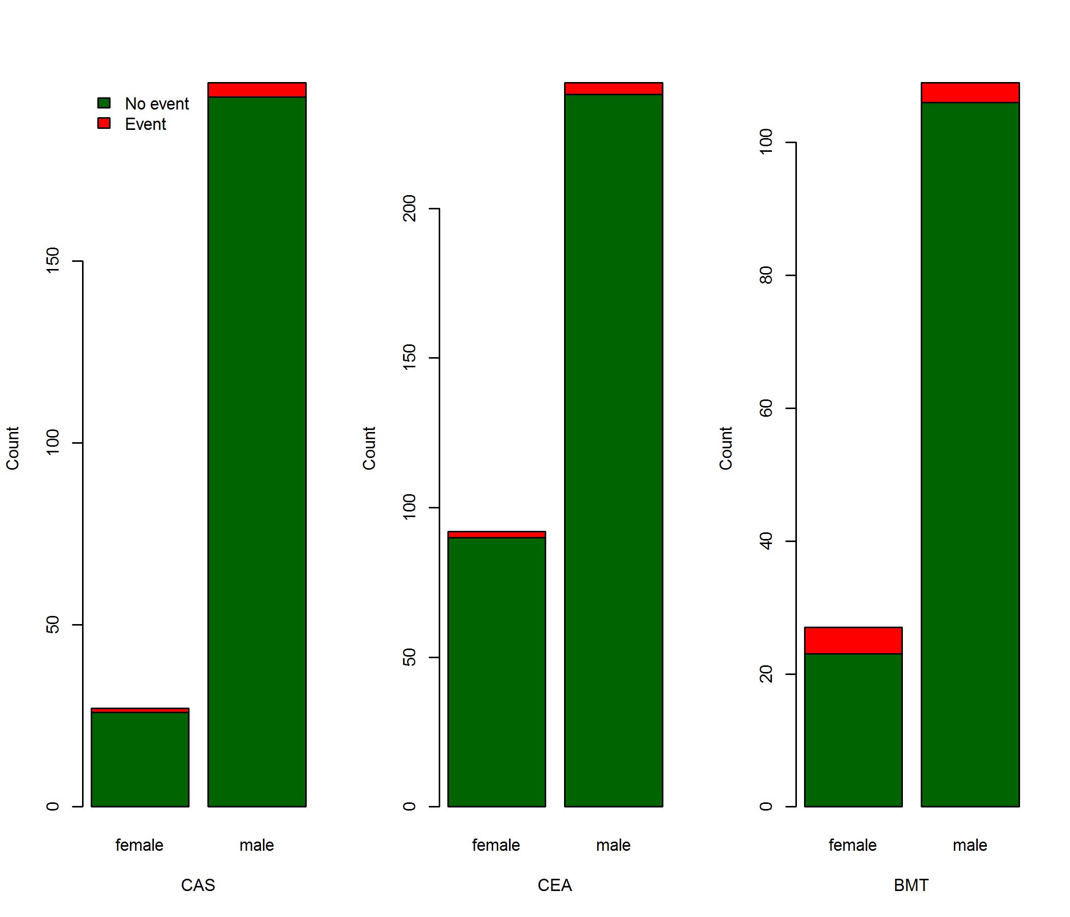

Visual distribution of gender within the three treatment groups was assessed.

Footnotes: Distribution of male and females within the treatment groups.

Abbreviations: CAS: carotid artery stent; CEA: carotid endarterectomy; BMT: best medical treatment

# Table S4 Restenosis, technical failure and cranial nerve injury

|  |  |  |
| --- | --- | --- |
|  | CEA (n, %) | CAS (n, %) |
| **Restenosis\*** |  |  |
| No | 277 (83) | 187 (83) |
| Stenosis 50-75% | 7 (2) | 3 (1) |
| Stenosis 75-99% | 4 (1) | 5 (2) |
| Occlusion | 0 (0) | 6 (3) |
| Unknown | 46 (14) | 26 (11) |
|  |  |  |
| **Technical failure** |  |  |
| No | 306 (92) | 201(89) |
| Yes** | 0 (0) | 0 (0) |
| Unknown | 28 (8) | 26 (11) |
|  |  |  |
| **Cranial nerve injury** |  |  |
| No | 303 (91) | NR |
| Yes | 2 (1) | NR |
| Unknown | 29 (8) | NR |

*No information is available on symptomatic versus asymptomatic restenosis and the given treatment.

**In three patients the internal carotid artery was ligated because of no perioperative back bleeding. This was not scored as a technical failure.

Abbreviations: CEA: carotid endarterectomy; CAS: carotid artery stenting; NR: not reported